Public Programmes Administrator
Recruitment Information

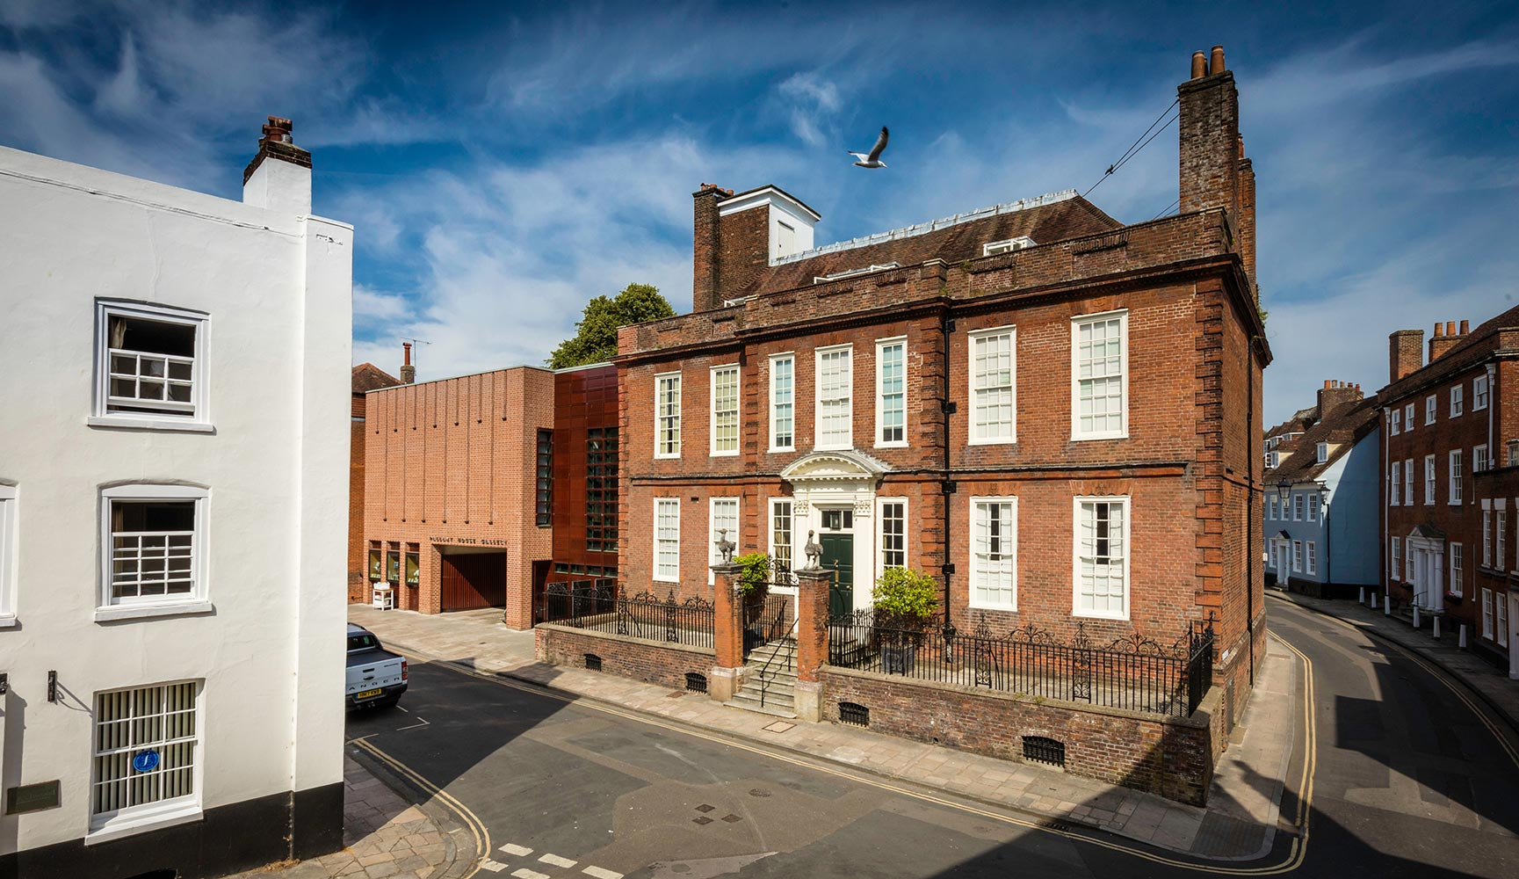

Closing date: Wednesday 28 August 2019, 17:00
First Interviews: Thursday 5 September 2019
Contents:
Welcome
Introducing Pallant House Gallery
The role and the department
Job description and person specification
Benefits and wellbeing package
How to apply
Equal opportunities
Welcome

Thank you for your interest in joining our dedicated and ambitious team as Public Programmes Administrator. This is an exciting time at Pallant House Gallery as we seek to expand our venue and attract new audiences.

You will find everything you need to know to make your application here. We look forward to receiving your application.

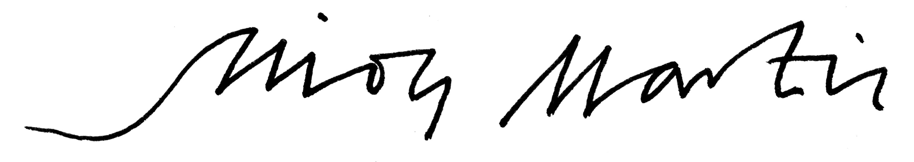

Simon Martin
Director

Introducing Pallant House Gallery

Pallant House Gallery is a leading UK museum that stimulates new ways of thinking about art.
We explore new perspectives on British art from 1900 to now through an ambitious programme of exhibitions and creative opportunities for all. We invite people from all walks of life to explore our world class collection in a distinctive setting in the heart of Chichester.

Our funding

We receive around 13% of our annual income from public funding. We are an Arts Council England National Portfolio Organisation (NPO), and receive annual support from Chichester District Council. We are reliant on fundraising, endowment income, admissions, sponsorship and commercial activity to cover our costs. 4,000 Pallant House Gallery Friends provide valuable income and support.

Our people

We employ 35 staff (17 full time, 18 part time) and are supported by 200 highly committed volunteers. We receive an average of 60,000 visitors a year.

What makes us different?

Original exhibitions

We present exhibitions that say something new about British art from 1900 to now. We explore relevant subjects with fresh angles and celebrate well-known, overlooked and emerging artists.

A ‘collection of collections’

We care for a world class collection of Modern British and contemporary art, largely formed of donations by passionate collectors over 35 years. We continue to make it accessible and show its relevance to today.

A part of people’s creative lives

Our wide range of creative opportunities for people of all ages and backgrounds helps them to discover how art can have a place in their lives.

A distinctive home

We welcome visitors to the distinctive setting of an 18th century townhouse and a 21st century gallery in the heart of historic Chichester on the south coast of England.

The Role and the Department

We are recruiting for an Administrator in the Public Programmes team at Pallant House Gallery, who will work across our three programme strands of Community, Adults and Schools & Families.

A new three year Public Programme Strategy for the Gallery has just been launched with the following aims:

- Ensure everyone feels welcome at the Gallery
- Show the benefits of leading a creative life and provide opportunities to do this
- Increase number and diversity of visitors to better reflect local, regional and national populations

The Public Programmes Administrator will have a key role in supporting a dynamic and busy team, in particular to enable more programmes to be launched in the next two years.

We are looking to appoint a candidate who has good experience of administration and creating systems to streamline the day-to-day workings of a team. Familiarity with and a keen interest in art-based community and learning programmes would be very welcome, as well as clear communication skills and confidence in working with children, young people, adults and community groups.

The post holder will be line managed by one of our Public Programmes Managers and work closely and collaboratively to support everyone in the team: three Public Programme Managers (Community, Adult and Access & Engagement), two Learning Coordinators and the Head of Public Programmes. The post holder will be required to work some flexible hours and some weekends.

Job Description

Salary: £17,550
Contract: Full time (37.5 hours), 2 year contract
Reporting to: Public Programmes Manager

Key Responsibilities
- To oversee the administration of the Public Programmes department and supporting the team to deliver the Public Programmes Strategy through coordinating and delivering a high quality Community Programme, Schools & Young People’s Programme and Adult Programme.
- Assist the team to deliver one-off projects, events and visits where relevant, and support the coordination of Public Programme related exhibitions, including the annual Community Programme Fundraising exhibition
- Working closely with the Public Programmes Managers, assist in ensuring all Community Programme sessions are delivered effectively, which includes: manage bookings and create registers, arrange volunteer support, introduce the session, ensure refreshments are provided, assist facilitators and educators when needed and collect participant numbers and feedback where necessary
- Process invoices and manage petty cash for the department
- Answer general enquiries about our work, fielding specific enquiries to the relevant team member
- Support all training sessions for Public Programme volunteers, freelance artist educators, student placements and Community Programme Ambassadors
- Administer the department’s entries on the organisation’s online database, Spektrix, ensuring that all data and lists are up to date, accurate and secure
- Administer the department’s DBS online checks
- Oversee the purchase of general materials for the department and the programmes we run, including refreshments, and keep these stocked up
- Working closely with other members of the Public Programmes team, volunteers and artist educators, lead on keeping the Studio clean and tidy
- Support the collation of important evaluation data from all programmes, including assisting on the production of the Annual Review for all members of the Community Programme
- Support the communication of opportunities and events to participants where relevant, in particular regular emails and newsletters to Community Programme members and invitations to Private Views
- Develop and maintain strong working partnerships and relationships with the team and other teams within the organisation (Curatorial, Communications, Development, Front of House)
- Be an enthusiastic advocate for collaboration, well-being and innovation across the team and the Gallery

This job description outlines the principal responsibilities and duties of the post holder. It is not meant to be, nor is it, an exhaustive list of specific responsibilities and duties. The post holder will be expected to undertake any other duties which could reasonably be expected as being within the remit of the post.
Person Specification

Essential
- Can-do attitude with an approachable and open attitude
- Excellent team-working and inter-personal skills
- Experience of working in an inclusive way with a diverse set of people
- Excellent organisational and administrative skills
- Good IT skills, in particular Excel and Microsoft Outlook as well as confidence in using equipment such as iPads, projectors and sound systems
- Ability to work effectively on multiple projects/tasks and ensure deadlines are completed
- Ability to use initiative, generate ideas and streamline systems
- Experience of working with and supporting freelancers and volunteers
- Excellent customer service manner
- Demonstrable commitment to equality, non-discriminatory practice, collaboration and well-being

Desirable
- An interest in and knowledge of 20th Century British Art and Contemporary Art
- Experience of creating accessible communication
- Interest in developments in learning and engagement for all age groups, with ability to incorporate this into the Gallery’s best practice wherever appropriate
- Experience of organising events, trips and/or exhibitions
- Experience of creating and writing marketing material
- Experience of digital technology, social media and using websites
- Familiarity with issues surrounding local community engagement and how to provide inclusive access to all

Benefits and Wellbeing Package

Benefits

Holiday Allowance
- 25 days basic holiday allowance
- Extra day off each year to celebrate a birthday or other occasion

Pension
- Auto Enrolment scheme. Currently a 3% contribution from Pallant House Gallery

Travel Support
- Interest free loan scheme for annual season tickets for trains
- Interest free loan for annual car park permits

Wellbeing Package

Discounts and free offers
- 20% discount in the Pallant House Gallery Restaurant and Café (excluding Saturday)
- 10% discount in Pallant House Gallery Bookshop
- Free admission tickets to the Gallery for family and friends
- Free tickets to Gallery talks
- Free copies of the lead exhibition catalogues and Gallery Magazine
- Free Preview tickets for Chichester Festival Theatre (subject to availability)
- Free Curator’s Art Pass through the Art Fund.

Health & Wellbeing
- Fresh organic fruit provided weekly in the staff room
- Annual flu jab
- Free sanitary products
- Offer of health and wellbeing related counselling (up to six sessions, subject to the confirmation of the session rate) for staff on request from your line manager

Please note that the wellbeing package is not contractual and may be subject to change.
How to apply

Please download an application form from our website.
You may attach a letter but please do not send photographs.
We do not accept CVs.
pallant.org.uk/who-we-are/our-people/work-with-us/

Please return the application form by email to:

humanresources@pallant.org.uk

Please use ‘Public Programmes Administrator application’ in the email subject line and name the application form document using the format: Full name, PP Administrator, date

or by post to:

Human Resources
Pallant House Gallery
9 North Pallant
Chichester
West Sussex
PO19 1TJ

Deadline for receipt of applications:
The deadline for this role is 17:00 on Wednesday 28 August 2019. Any forms received after this time will not be processed.

Acknowledgement of receipt
Email applications will be acknowledged by auto response when we receive them.

Candidates not selected for interview will be informed by email. We regret we cannot enter into correspondence as to the reasons for non-selection.

Equal Opportunities

Pallant House Gallery is an equal opportunities employer.

If you wish you can download an equal opportunities monitoring form from our website. Completing this form is entirely voluntary and plays no part in the recruitment process. It will be used solely to monitor the people applying for the post.

